Name :Abhay Pratap Singh
Btech :CSE A
Roll no:202401100200008
. GitHub repository URL
https://github.com/abhay9901/github-skills-challenge
….2.
. Pull request URL used to validate the workflows
https://github.com/abhay9901/github-skills-challenge/pull/3

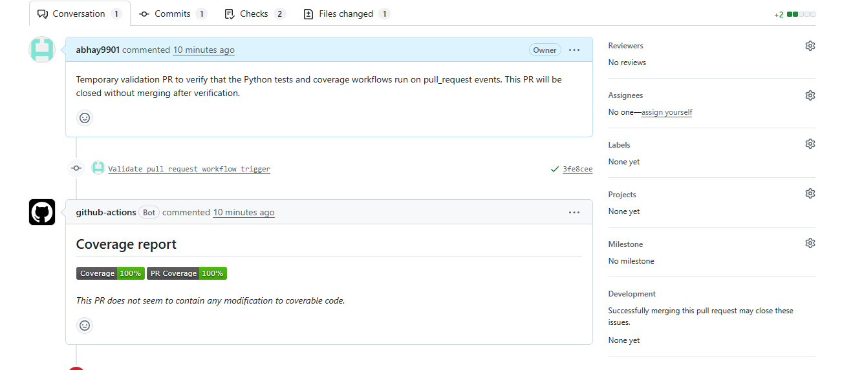
3. Screenshot showing the GitHub Actions workflows
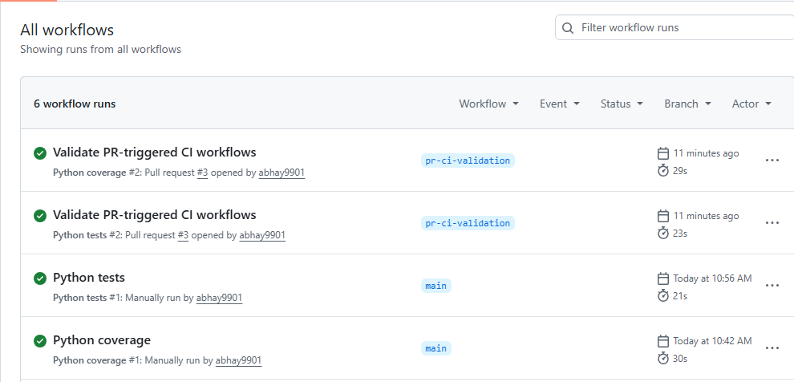
4. Screenshot showing a successful test workflow execution
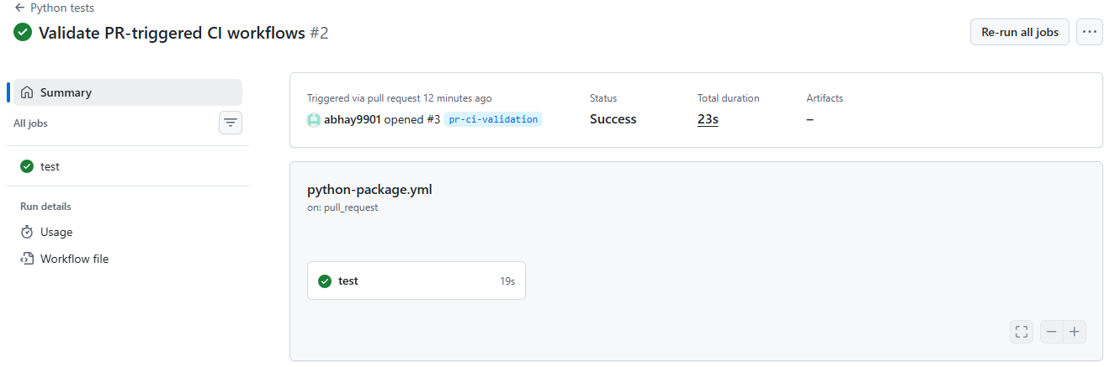
5. Screenshot showing the coverage result/comment on the pull request
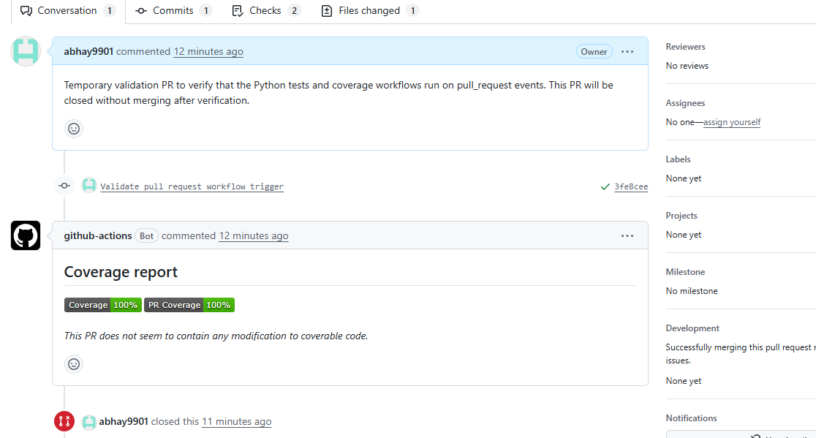6. . Screenshot showing the final repository/workflow files
